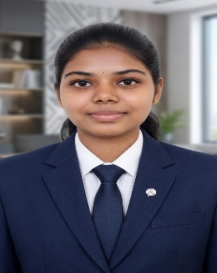
ARTHI K
✉ : aarthiishu22@gmail.com
☎ : +91 9894727305
📍: 1/15 A, Gomangalam Pudur, Police Station Road, Pollachi, Coimbatore District. 642107

PROFESSIONAL SUMMARY

Motivated B.E. Computer Science and Engineering student (CGPA: 8.3) with hands-on internship experience in Java development and Android app development. Proficient in Java, Python, and HTML with strong communication skills and a proactive attitude toward learning and teamwork.
EDUCATION

V.S.B. College of Engineering Technical Campus, Coimbatore. 2023 – Present
- B.E. Computer Science and Engineering CGPA : 8.3

Government Higher Secondary School, Gomangalam Pudur. 2022 – 2023
- HSC (12th) : 8.3%

SKILLS

- Programming Languages: Java, Python, HTML
- Tools : Google Sheets, VS Code
- Soft Skills: Communication, Adaptability, Team Collaboration, Problem Solving
- Languages: Tamil, English

CERTIFICATIONS

- Java – Infosys Springboard Dec 2024
- Data Science and Analytics – HP LIFE online course April 2026

INTERNSHIPS

Java Intern – Online Jun 2025 – Jul 2025
- Gained hands-on experience in Core Java concepts including OOP, exception handling, and collections framework.
- Developed small-scale applications and strengthened understanding of Java-based development workflows and best practices.

App Development Intern – Online Jul 2024 – Aug 2024
- Learned Android app development covering activity lifecycle, XML UI design, and intent-based navigation.
- Designed basic Android applications and gained exposure to deployment processes and mobile UI/UX best practices.

CAREER OBJECTIVE

To obtain a challenging position in a reputable organisation where I can utilise my skills in Java, Python, and application development, contribute to team success, and grow as a software professional.
DECLARATION

I hereby declare that the above furnished details are true and correct to the best of my knowledge.

